Task One

* 2==4 – Equals – False
* 5 > 3 – Bigger than – True
* 4 >= 4 – Bigger than or equal to – True
* 3 < 2 – Smaller than – False
* 7 <= 7 – Smaller than or equal to – True
* 8 != 9 – Is not equal to – True

Task Two

* Test_score == 50 – Equals – False
* Test_score > 40 - Bigger than – True
* Test_score >= 60 – Bigger than or equal to – False
* Test_score < 40 – Smaller than – False
* 50 <= Test_score – Smaller than or equal to – True
* 56 != Test_score – Is not equal to – False

Task Three

* True and True = True
* True and False = False
* False and True = False
* False and False = False
* True or True = True
* True or False = True
* False or True = True
* False or False = False
* Not(True) = True
* Not(False) = True
* Operator when it evaluates to True (and) – True and True
* Operator when it evaluates to True (or) – True or True, True or False, False or True

Task Four

1. Test_score is assigned to the value 56
2. It then says if test_score >= 50 it will print “pass”. This means that if the test_score is equal to or higher than 50 then it will say that you have a “pass”.
3. It then says if test_score < 50 it will print “fail”. This means that if the test_score is under 50, then it will say that you have a “fail”.
4. This means that it is going to print “pass” as the test_score has been assigned to 56 and that is higher than 50.

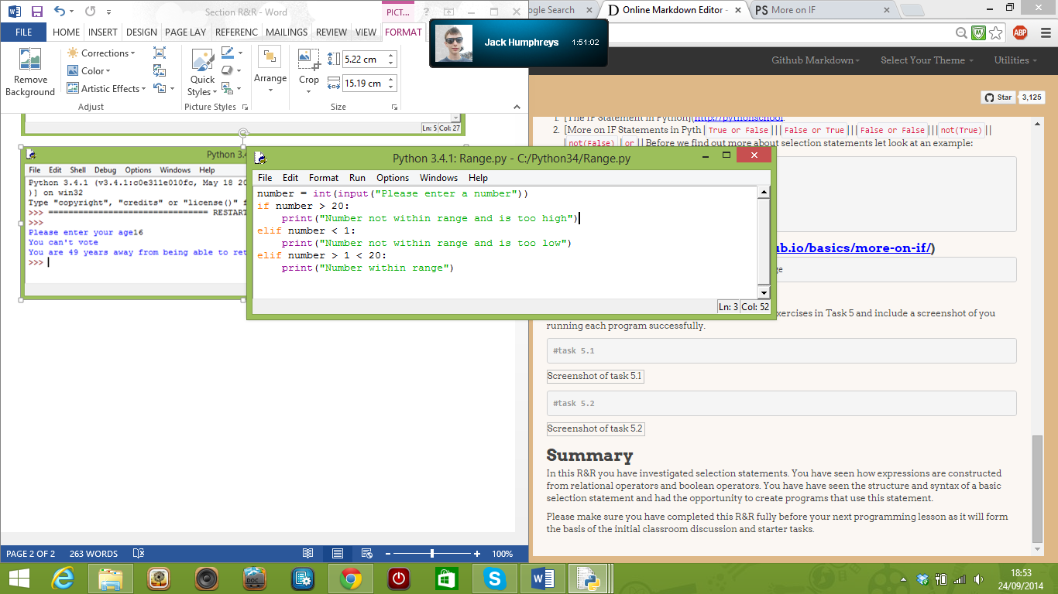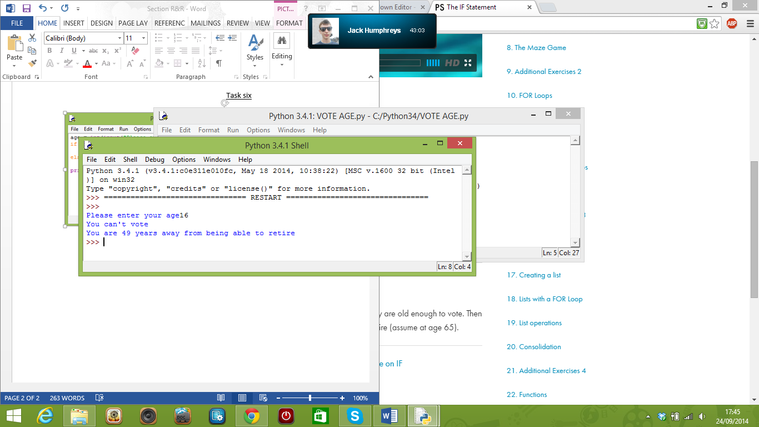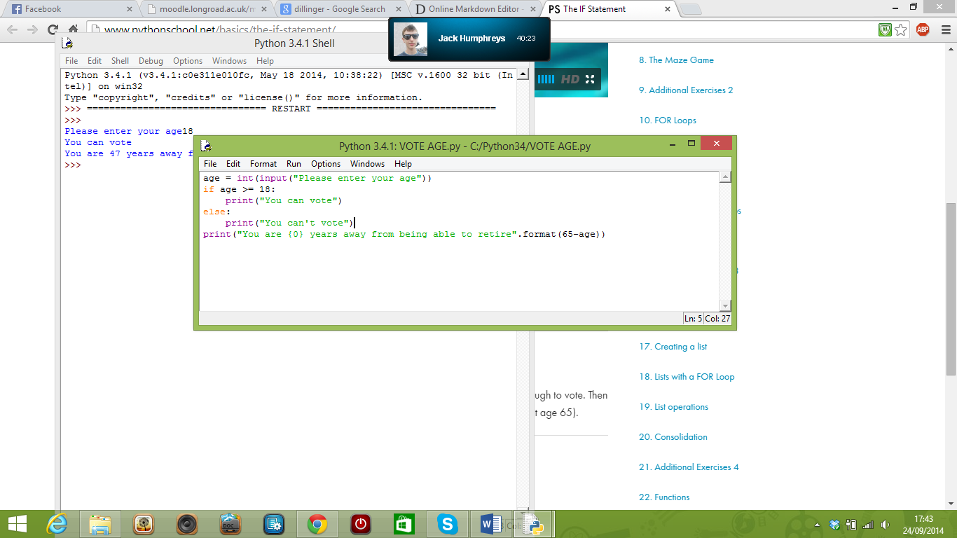Task six

